





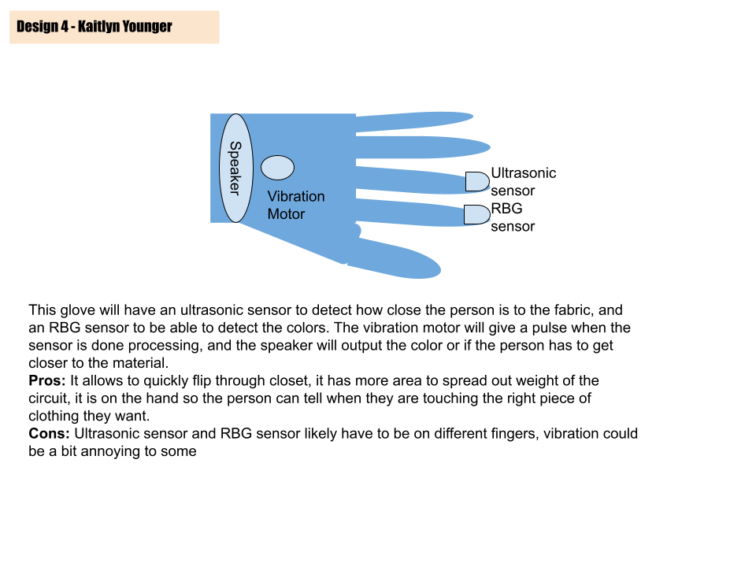

| **Criteria / Requirements** | **Weighting** | **Design Idea 1**  **Ratings** | **Design Idea 2**  **Ratings** | **Design Idea 3**  **Ratings** | **Design Idea 4**  **Ratings** |
| --- | --- | --- | --- | --- | --- |
| No intrusive | 6 | **6**\*6=36 | **6**\*6=36 | **6**\*6=36 | **6**\*6=36 |
| Usage of battery / power source | 7 | **8**\*7=56 | **8**\*7=56 | **7\***7=49 | **8\***7=56 |
| Input sensors | 8 | **9**\*8=72 | **8**\*8=64 | **7\***8=56 | **8**\*8=64 |
| Outputs / feedback | 9 | **8**\*9=72 | **6**\*9=54 | **8\***9=72 | **8**\*9=72 |
| Wearability | 7 | **6**\*7=42 | **7**\*7=49 | **7\***7=49 | **7**\*7=49 |
| Fashion | 4 | **5**\*4=20 | **8**\*4=32 | **7\***4=28 | **5**\*4 = 20 |
|  | Total | **298** | **291** | **292** | **297 (winner by discussion)** |